DEVELOPING EMERGING LEADERS AND TALENT
IN AGRICULTURE (DELTA)
SCHOLARSHIP, RESEARCH GRANT AND SYMPOSIUM

About DELTA
Corteva Agriscience, a global pure-play agriculture
company focused on enriching the lives of those who produce and those who consume, invites under- represented minority undergraduate and graduate students, as well as postdocs, to register for a program called DELTA. Ideal participants are interested in a career in agriculture and want to learn more about sustainable and reliable food production.
DELTA is led by members of Corteva Agriscience Research and Development (R&D). It offers eligible candidates an opportunity to participate in a R&D symposium, which will provide a technical overview of the company, and a chance to share their research, network and develop soft skills that are essential to any industry career.
This program also includes an opportunity for students and postdocs to secure a research grant (graduate) or scholarship (undergraduate). Awardees will have the opportunity to engage with an industry mentor.

Apply for the DELTA program in a single application.

Participants Requirements
Symposium participants should be a rising undergraduate
senior, masters or doctoral student or post-doc within 1 year of completion studying in a technical discipline.
Students that do not meet the criteria above can consider applying for the Corteva DELTA research grant/scholarship. Applicants should expect to receive their degree by December 2024.
Preferred disciplines include biology, biochemistry, biological/ agricultural engineering, analytical chemistry, organic chemistry, data and computer sciences, chemical engineering, genomics, material sciences, molecular biology, plant breeding and closely related fields.
Providing growth and development opportunities equitably for all talent is essential to our ability to realize our Inclusion, Diversity & Equity (ID&E) vision and nurture a strong, diverse talent pipeline within our industry. DELTA aims to offer opportunities specifically to under-represented U.S. racial/ ethnic minorities in STEM as defined by the National Science Foundation, which include those who identify as African American or Black, Hispanic or Latino, and American Indian or Alaska Native. Non-U.S. citizens are eligible for participation if they meet the targeted audience requirements.
Application deadlines are June 3, 2022.

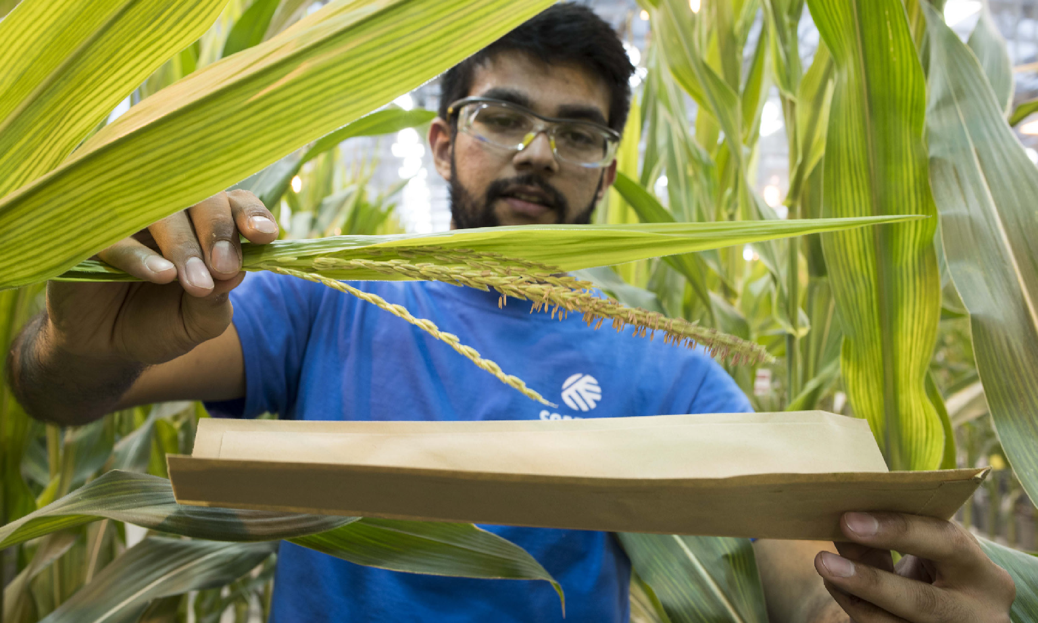

ed companies. © 2022 Cortev

